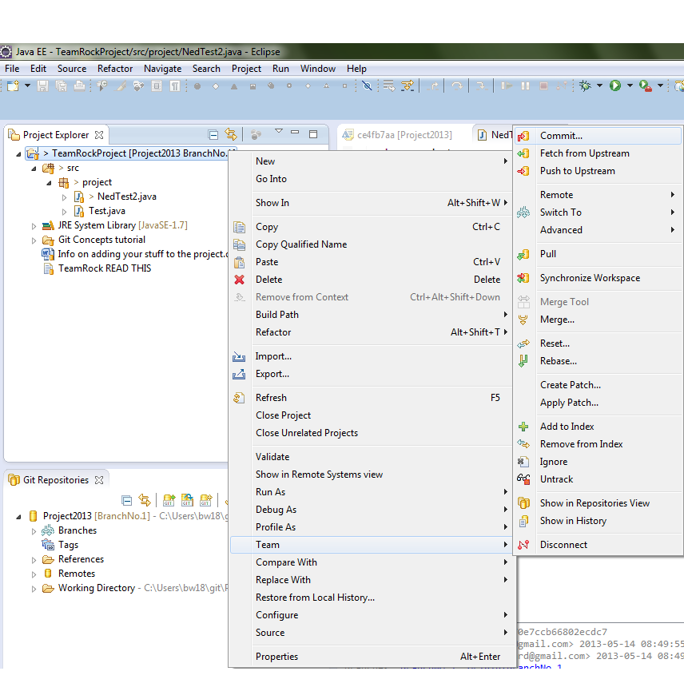

Here a user has changed a file in TeamRockProject – This is how you commit the changes to the remote repository